**Tile Questionnaire**

**Sizing:** How large of a tile shower would you like? Standard size, large walk in, etc.

**Layout:** Do you want tile on the floor, or would you like a fiberglass bottom? Do you want tile on the ceiling?

**Entry Preference:** What kind of entry would you prefer?

Frameless glass door

Curbless walk in (new construction only)

**Configurations:** Do you want any additional configurations like a niche or a bench?

**Additional Information:** Do you want a specific design or pattern done with the tile? Do you have any inspirational photos?

**Do you have a tile preference?** Ceramic, Porcelain, Marble etc.

**If Applicable:** Would you prefer Bullnose or Schluter ediging?

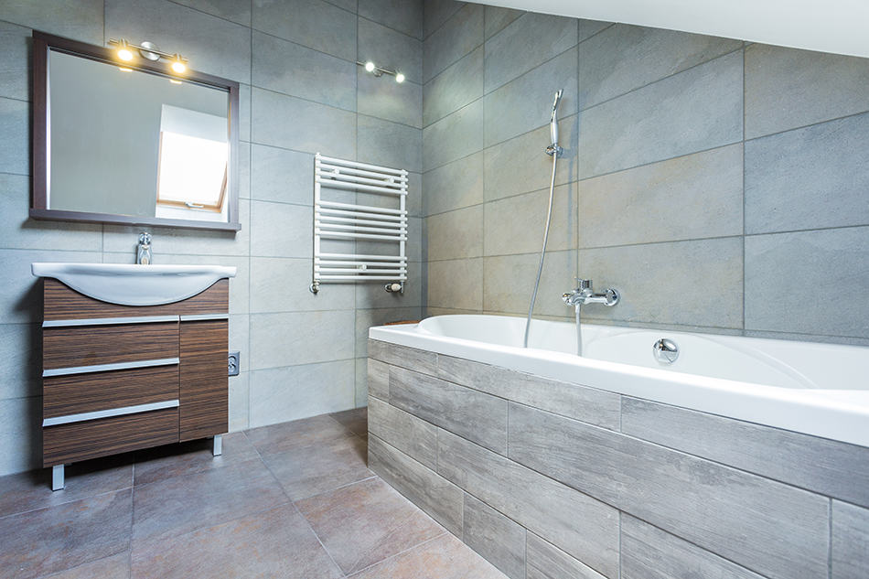**Ceramic**

Easy to Clean

Moisture Resistant

Durable

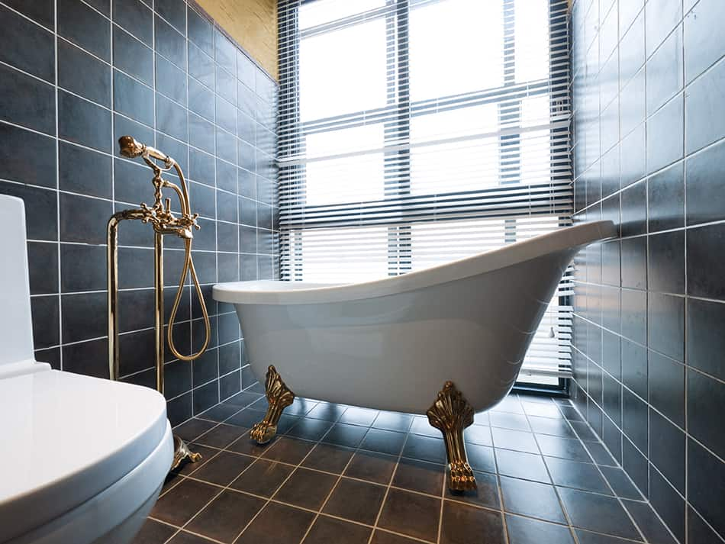**Porcelain**

Higher Quality but more costly

Very Easy to Clean

Scratch, Moisture & Stain Resistant

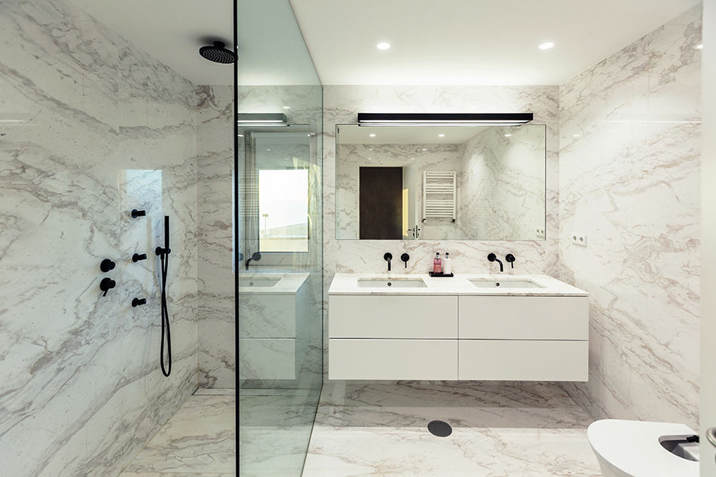

**Marble**

Higher Quality but Expensive

Highly Porous

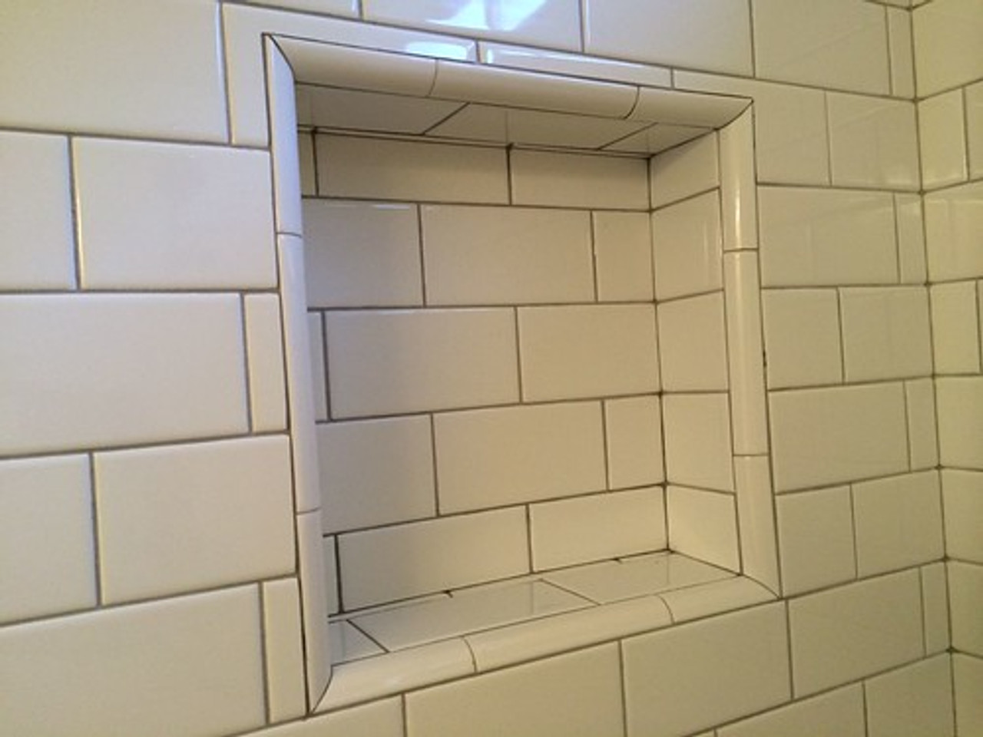**Bullnose**

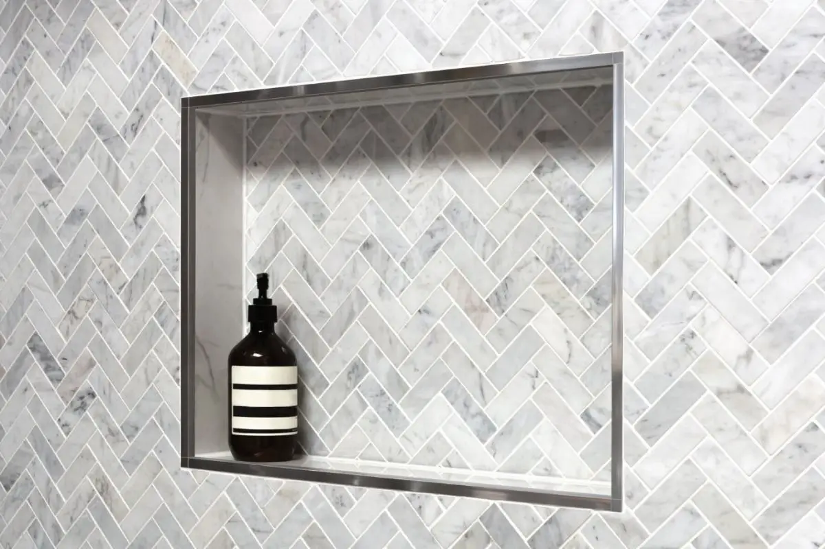**Schluter**